Milk Paint
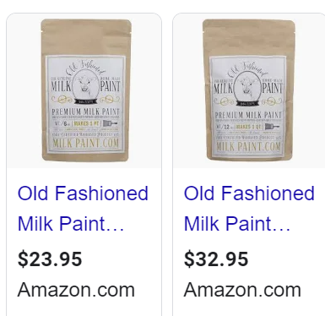
1 PINT 1 Quart
Wooden Craft Sticks
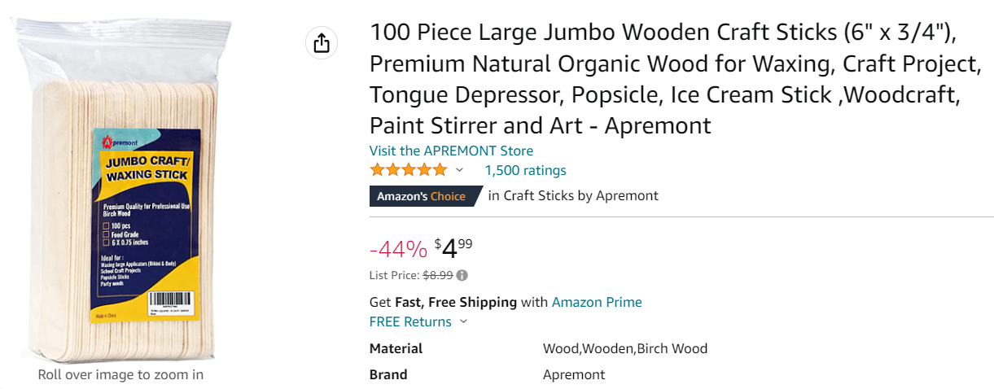

Lidded Plastic Jars 4 oz
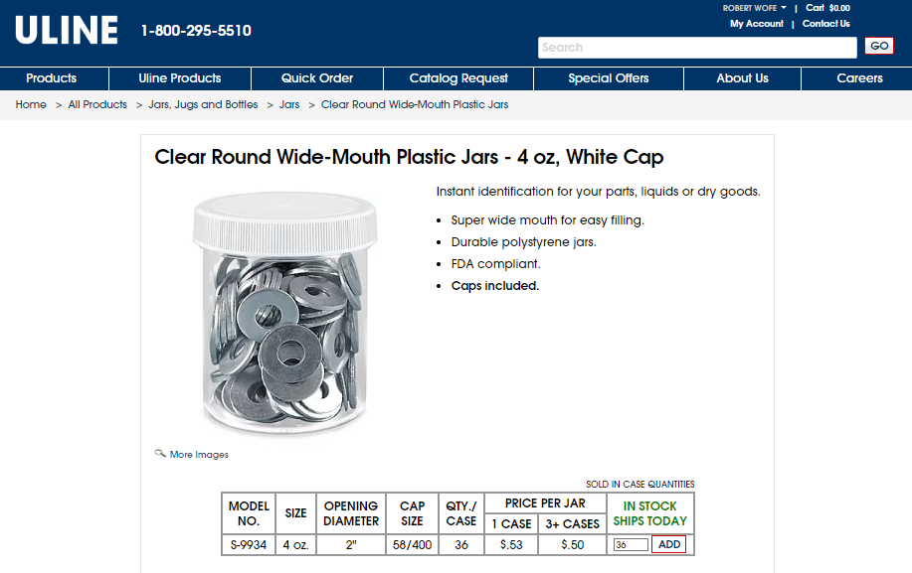
Craft Brushes

Strainer
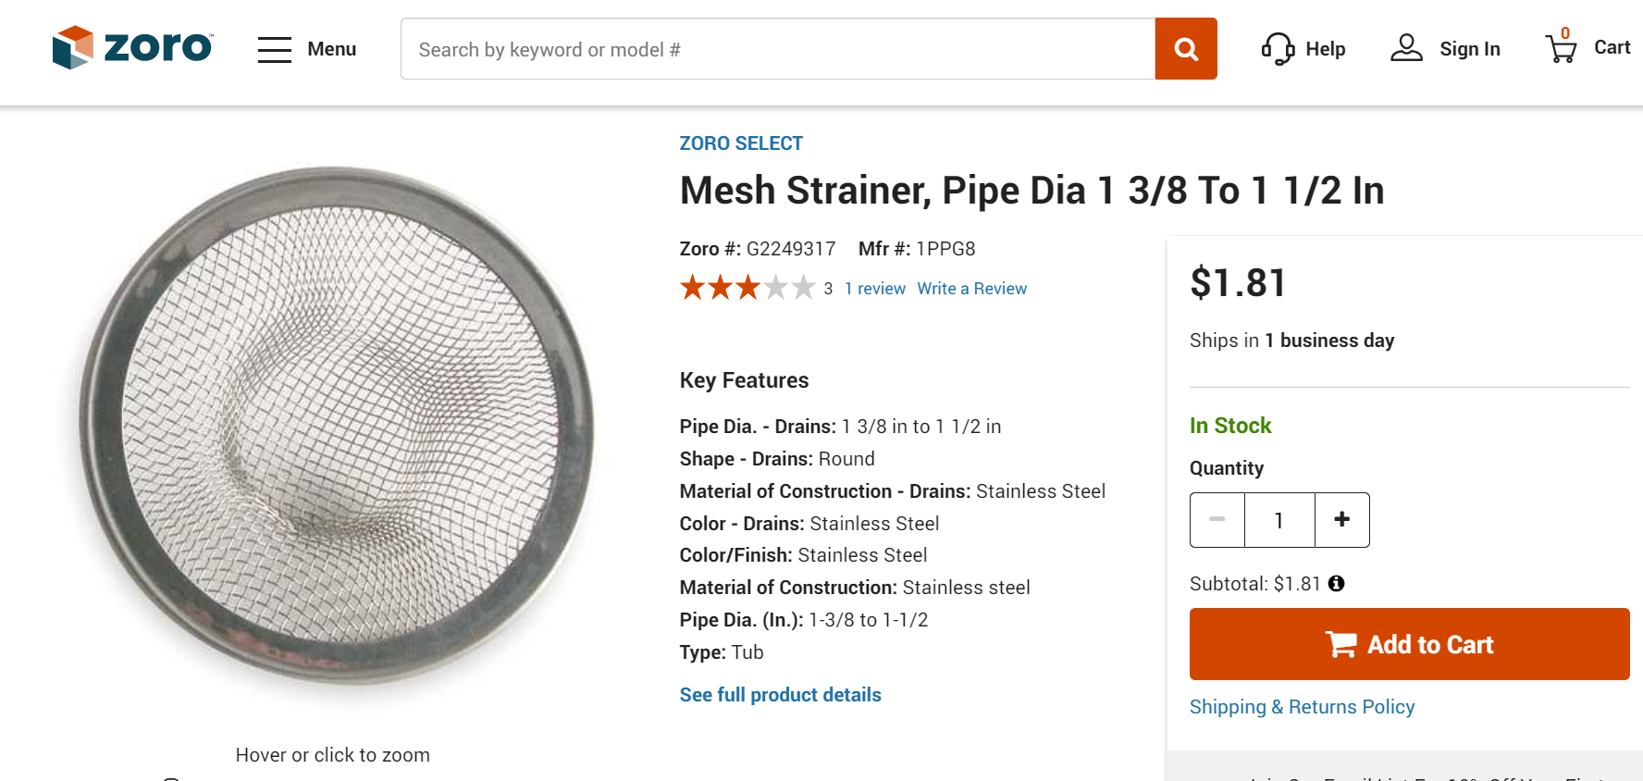
Microplane
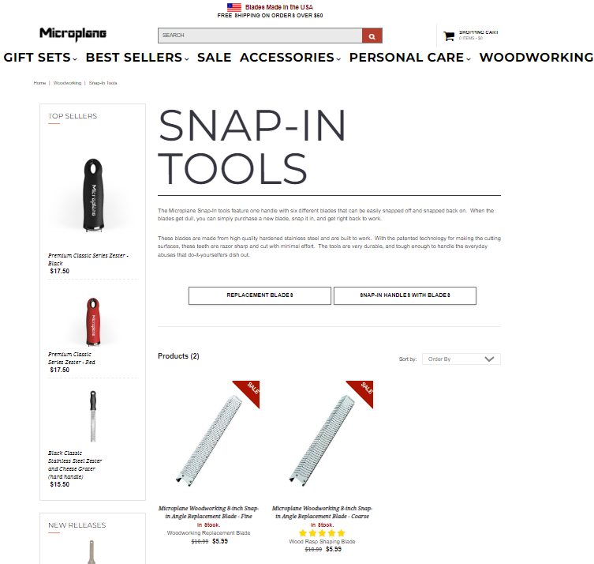
0000 Steel Wool
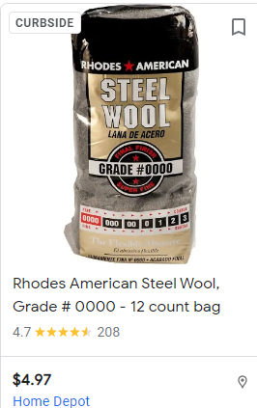
Wipe-On Poly
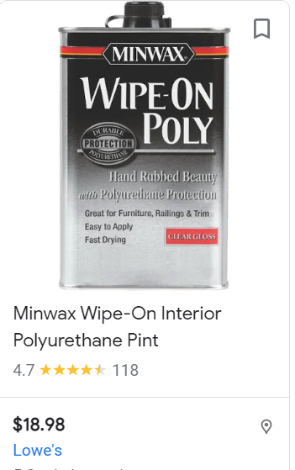

Walnut Oil & Bees Wax
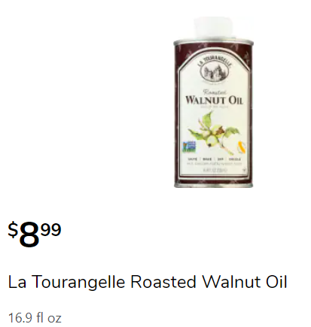 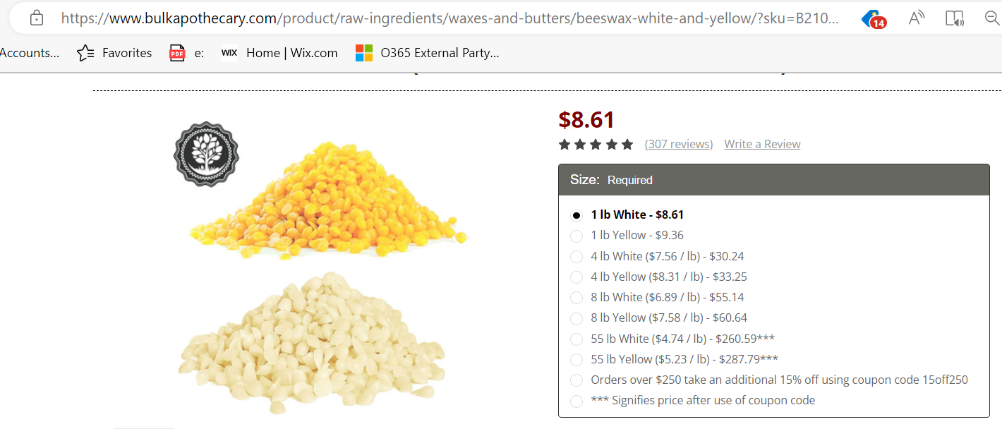 Kroger has in stock On Line

Mixture is 1 part Bees Wax & 4 parts Walnut Oil.
- In a double boiler, heat up pellets of Bees Wax until liquified
- Add Walnut Oil to liquified bees wax and mix thoroughly
- Pour into suitable container and let is cool.
- Apply paste to raw wood or burnished Milk Paint using a paper towel with lathe off
- Once the surface is coated with past turn on lathe to relatively high speed and work paste into the turning.
- Take a clean paper towel and increase speed to 1500 rpm and buff to a nice luster.

